

# TABLE OF CONTENTS

|  |  |  |  |
| --- | --- | --- | --- |
| **S**  **No.** | **Contents** | **Page No.** | **Sign** |
| **1** | **Abstract** | **1** |  |
| **2** | **Objective & Introduction** | **2** |  |
| **3** | **Component Description** | **4** |  |
| **3** | **Aim & Component Description** | **6** |  |
| **4** | **Screenshots** | **9** |  |
| **5** | **Conclusion** | **12** |  |
| **6** | **References** | **13** |  |

# OBJECTIVE

The main goal of this work is to make a fully automated IoT environment to make an efficient fire prevention system by adding required IoT devices.

# INTRODUCTION

Internet of things is an interconnection of physical devices embedded with electronics, software, sensor which is capable of collecting data from the surrounding and sending data over internet is called IoT. The fire detection gathers all of the techniques and processes that contribute to early detection of a fire. We identify three main categories: Smoke detection, Flame detection and Temperature detection.

Automatic fire alarm system provides real-time surveillance, monitoring and automatic alarm. An automatic fire alarm system based on [wireless sensor](http://projectabstracts.com/tag/wireless) [networks](http://projectabstracts.com/tag/wireless) is developed, which is designed for high-rise buildings.

To provide early extinguishing of a fire disaster, large numbers of detectors which periodically measure smoke concentration or temperature are deployed in buildings. In this paper will we present the different techniques we had been already used to detect fire. Some of those techniques include fire detection using image process sing and sensors, fire detection using CCTV technology, Fire detection using ZigBee which is a kind of personal area network.

The image below describes the various use cases of IoT devices –

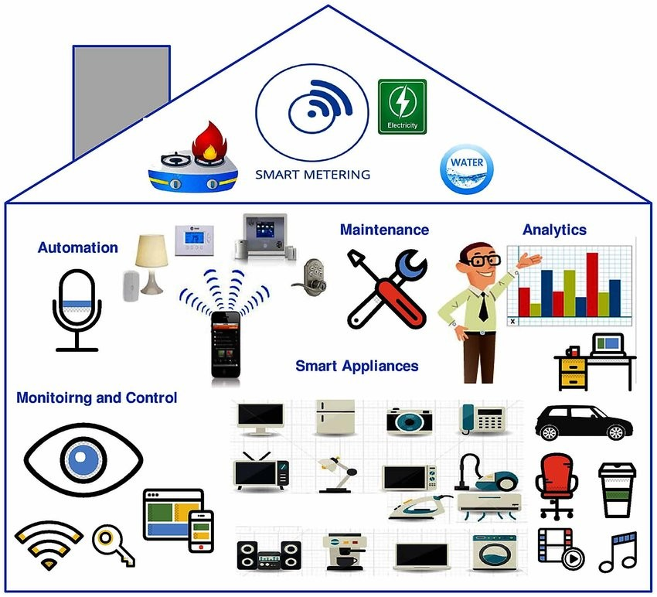

# COMPONENT DESCRIPTION

A gateway is a device that connects networks using different communication protocols in a way that allows for information to pass from one network to the other. It both transfers and converts the information into a form that can be used by the protocols on the receiving network. Think of it as a TCP/IP node that has routing capabilities. In other words, a gateway is a kind of router.

A router, by definition, is a device or computer that sends packets between two or more network segments as necessary, using logical network addresses, most often IP addresses.

The default gateway is the path used to pass information when the device doesn’t know where the destination is. More directly, a default gateway is a router that connects your host to remote network segments. It’s the exit point for all the packets in your network that have destinations outside your network.

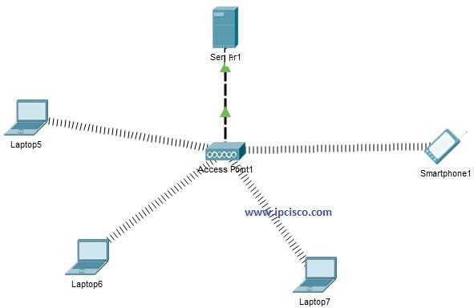



# School of Computing

**SRM IST, Kattankulathur – 603 203 Course Code: 18CSC302J**

# Course Name: Computer Networks

|  |  |
| --- | --- |
| **Experiment No** | CC Mini Project |
| **Title of Experiment** | Fire Prevention System |
| **Name of the candidate** | Vaibhav Jajodia |
| **Team Members** | Abhishek Gupta |
| **Register Number** | RA2011003010128, RA2011003010113 |

**Aim:** To build a fire prevention system for a parking lot

**Components Required:**

|  |  |
| --- | --- |
| **Devices** | **Required No.** |
| Server – PT | 1 |
| Access Point - PT | 1 |
| Sprinkler (IOT) | 1 |
| Smoke Detector (IOT) | 1 |
| Siren (IOT) | 1 |
| Window (IOT) | 1 |
| Old Car (IOT) | 5 |

**Addressing Table:**

|  |  |  |  |  |
| --- | --- | --- | --- | --- |
| **Name** | **Interface** | **IP**  **Address** | **Subnet Mask** | **SSI D** |
| Server0 | Fa0/0 | 192.168.1.1 | 255.255.255.0 | - |
| Access Point0 | Fa0/0 | - | - | Cisco |
| Sprinkler | Wireless | 192.168.1.2 | 255.255.255.0 | - |
| Smoke  Detector | Wireless | 192.168.1.3 | 255.255.255.0 | - |
| Alarm | Wireless | 192.168.1.5 | 255.255.255.0 | - |
| Window | Wireless | 192.168.1.4 | 255.255.255.0 | - |

**Procedure:**

**Step 1:** Drag all the required components (Server, Access Point, Sprinkler, Smoke Detector, Siren, Door) in the console area.

**Step 2:** Set the SSID as “Cisco” for Access Point0.

**Step 3:** Connect the server to the access point using Copper Cross-over Cable through the Fa0/0 interface.

**Step 4:** Connect all the IOT devices to the Access point wirelessly by specifying the SSID as “Cisco”

**Step 5:** To set up the registration server follow:

* Desktop Tab => Browser
* Type the URL as (http://192.168.1.1), then click on Sign up
* Set your desired user name and password

**Step 6:** Login to the registration server using the credentials set in the previous step.

**Step 7:** Add conditions for the IOT devices using the smoke detector as the trigger.

**Step 8:** Test the system using the cars to trigger the smoke detector

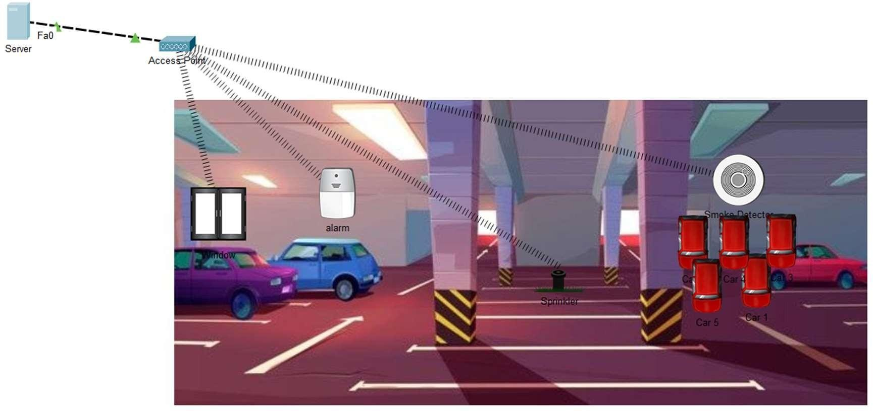

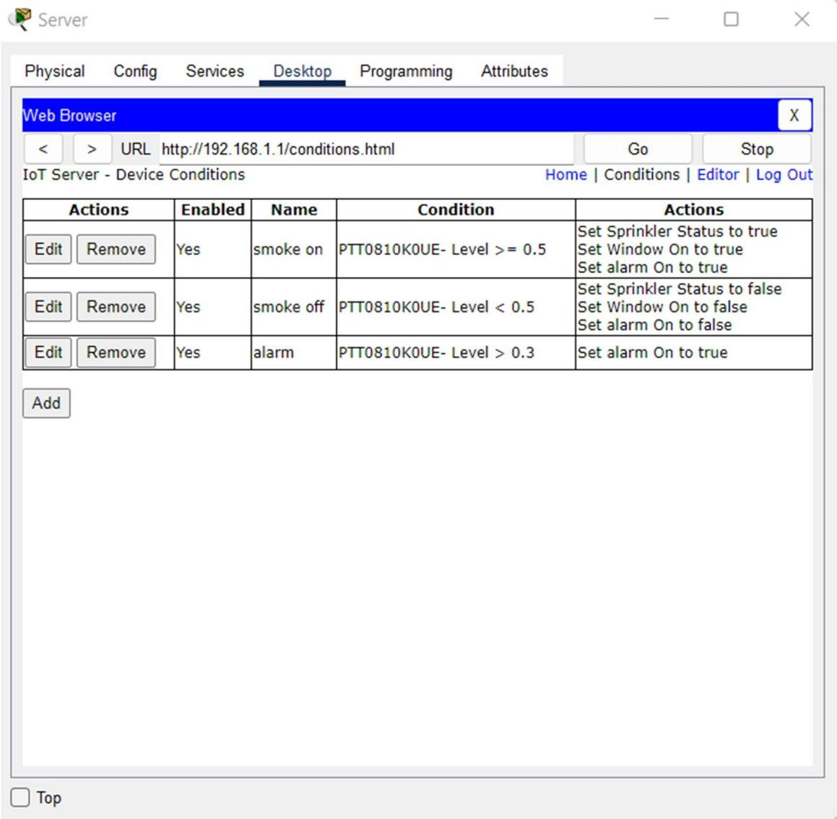

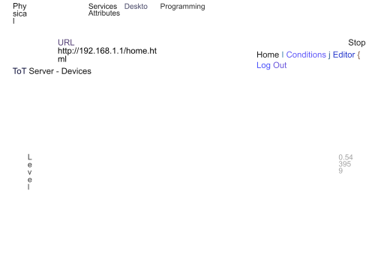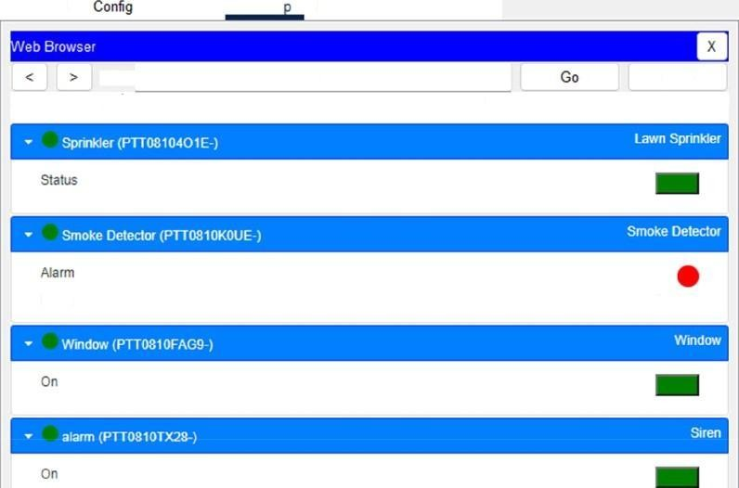

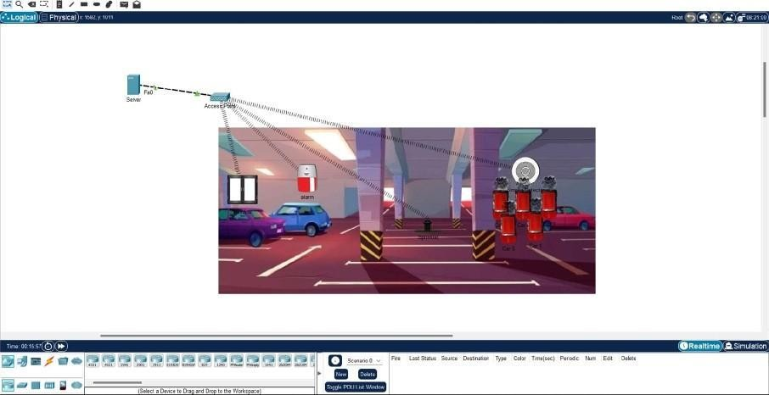

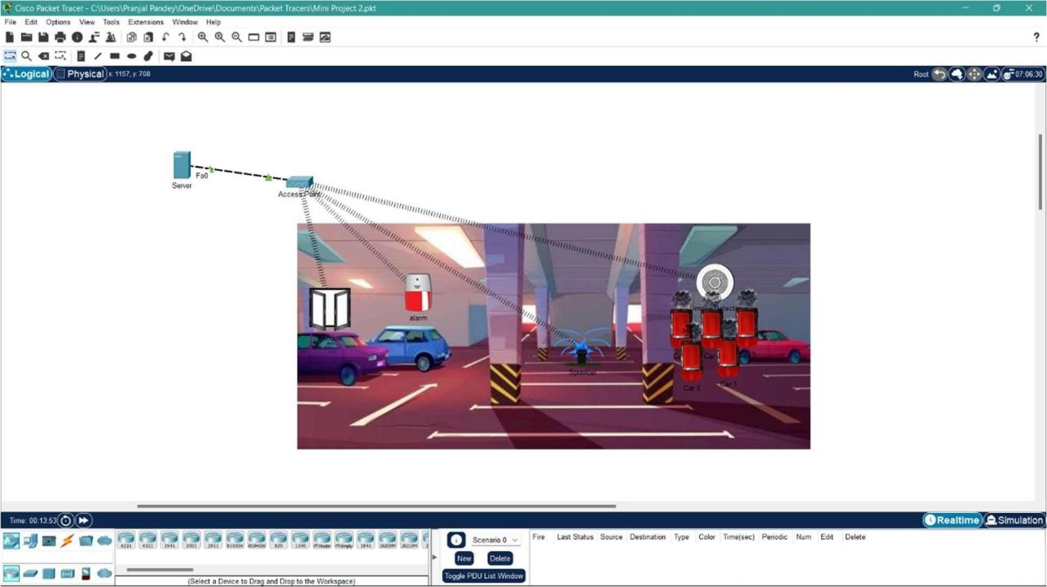

UML Diagrams:

1. **Use case** Diagram:

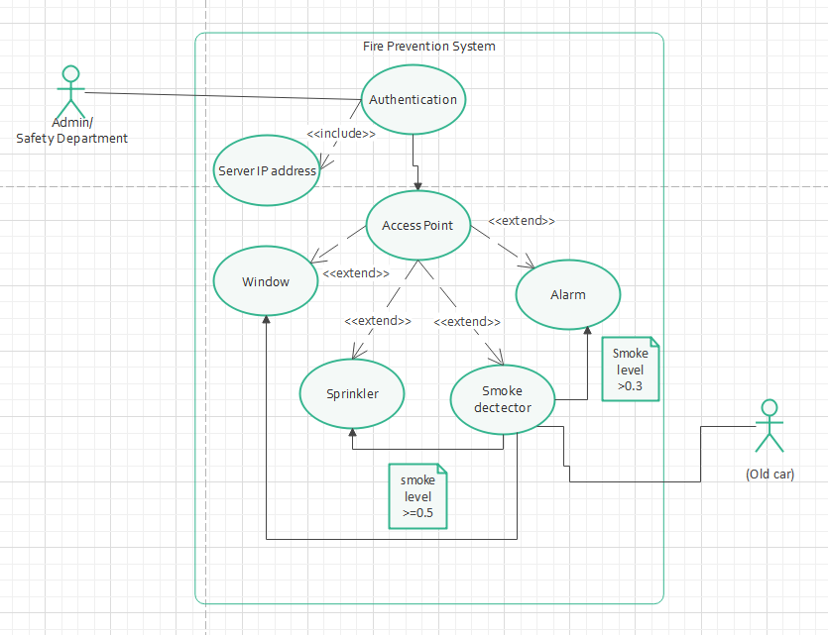

1. Sequence diagram:

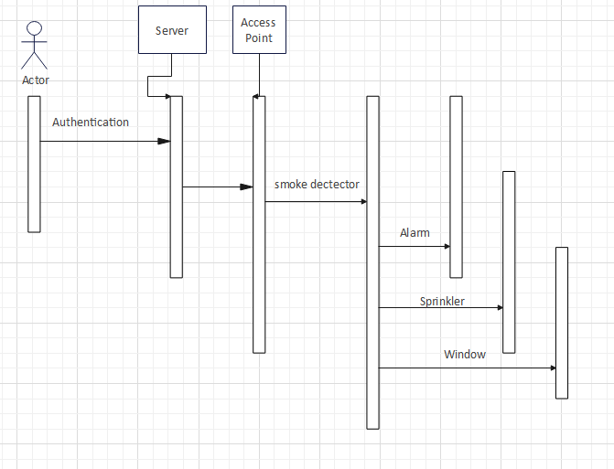

CONCLUSIONS

In this Project, the design and implementation of a IOT device management is carried out. The main goals are: to optimize the network resources, to give security and to provide real-time user monitoring, in order to avoid time wasting. As a result of this work, the solution implemented can be changed according to user requirements.

**Result:**

The fire prevention system has been successfully constructed and tested.

# REFERENCES

1. Book on Computer Networks

Andrew S. Tanenbaum, Computer Networks, Prentice Hall, Fourth Edition, 2002.

1. Internet of things https://en.wikipedia.org/wiki/Internet_of_things
2. Default Gateway https://[www.sciencedirect.com/topics/computer-science/default-](http://www.sciencedirect.com/topics/computer-science/default-)

gateway#:~:text=The%20default%20gateway%20is%20the,have%20destinations

%20outside%20your% 20network.

https://community.cisco.com/t5/cisco-software-discussions/packet-tracer-smoke-si mulation-sensor-problem/m-p/4509065